Monday 24rd November,

Dear Parents and Carers,
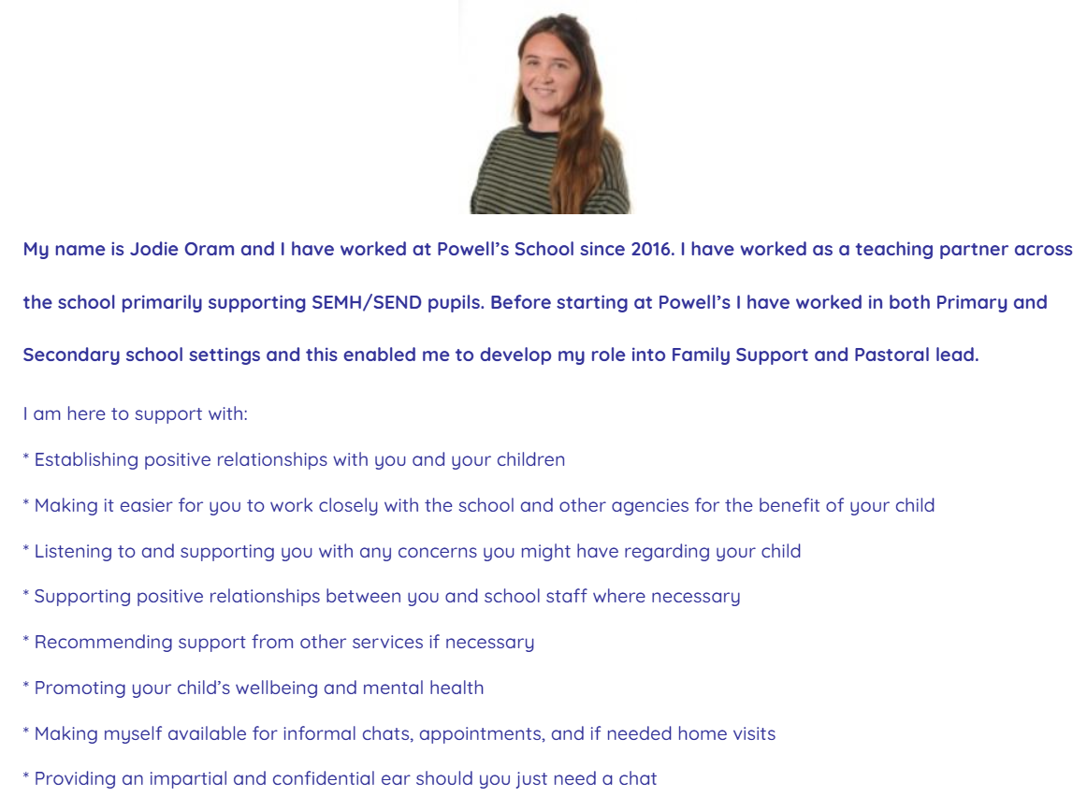
As part of our collaborative work with Powell’s, we are excited to introduce you to our new Family Support Worker. Jodie Oram has supported many children and families in different areas of school and family life. She will be working at Sapperton two Wednesdays a month, with our wonderful children and any families that would benefit from this support.

Please get in touch with admin@sapperton.gloucs.sch.uk, m.crampton@sapperton.gloucs.sch.uk, or directly with Jodie on 07554 309761 or familysupport@powells.gloucs.sch.uk should you like any more information. We look forward to working with Jodie and are pleased we can offer this incredible support to our families.
Yours faithfully,
Meg Crampton
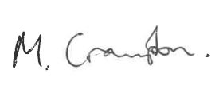

Head of School

